How to access Clever from home

Using Bing or Google search for
“cobb clever,” When selected it will take you to the screen below

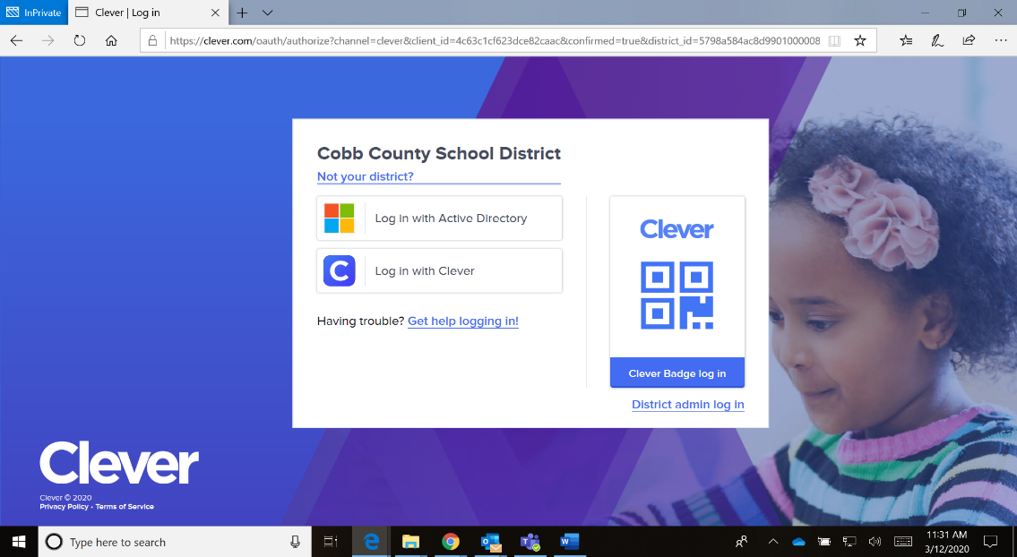

Click on Log in with Active Directory

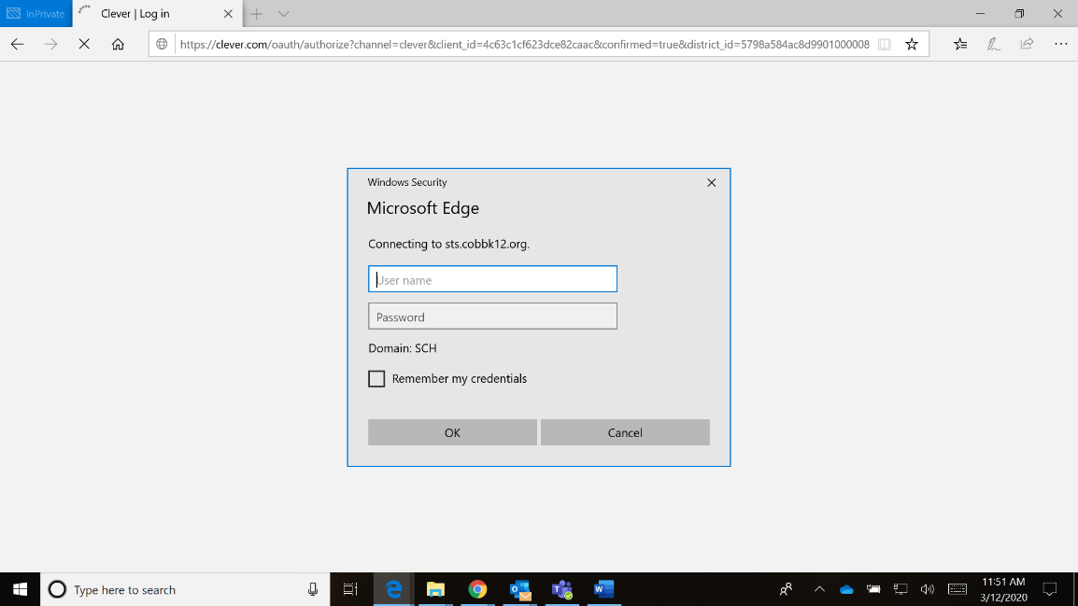
Logging in with Active Directory
Username: Office 365 login (firstname.lastname@students.cobbk12.org)
Password: computer password
If you cannot get logged in with Active Directory, go back to the screen above and log in with Clever. With this log in option, you will use your student ID (lunch number) will be used for user name and password. You will then be prompted to change your password.

