Directions for using NoodleTools
Sign into Noodletools
- Go to Cobb Digital icon on desktop
- Go to databases
- Search NoodleTools
- Create new account or sign in via O365 (signing in may take a few tries)
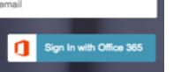

- Choose school (Lost Mountain)
- I am a student
- Date of graduation (2023)
New Project
- After you register, you will see the Projects screen
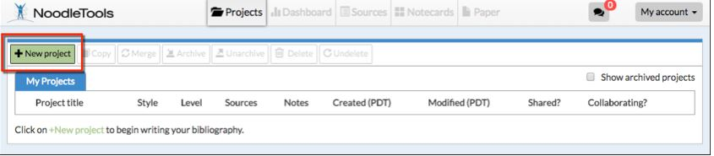
- Click on New Project
- Project Name: Argumentative Essay
- MLA style
- Citation level = Starter
- Click Submit

Dashboard Screen Appears
Type in the research question – Are vaccinations effective against disease?
Hypothesis – Vaccinations are effective in preventing the spread of disease.

Click on sources in the navigation bar
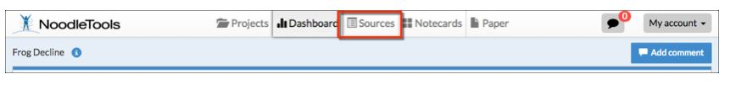
- Click Create new Citation
- Database, reference source
- If information is not available, leave blank
- On the Sources screen, click Create new citation and select the best match for your source from the choices given.
- You can locate a book with ISBN number or copy and paste a citation
- After you finish entering information about your source, click Submit to save your new citation.

Create Notecards
- Click Notecards in the navigation bar at top.
- On the Notecard Tabletop, click New.
- Enter information
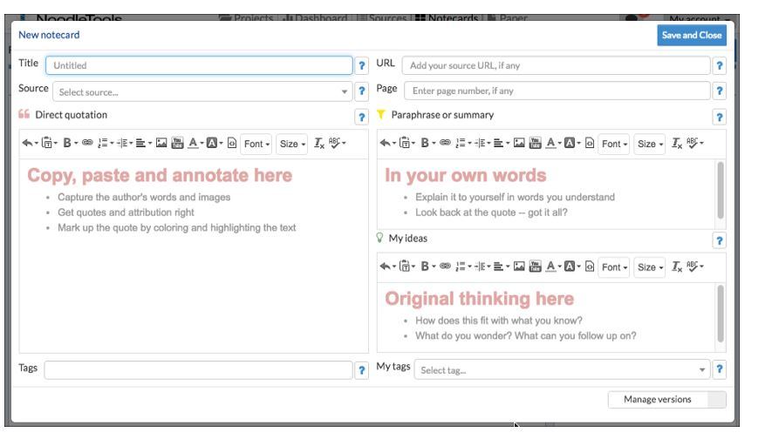
- Once you've created multiple notecards, you can pile them. Drag a notecard and drop it on another notecard to create a new pile, or use the Manage pile option above the tabletop to manage existing and create new piles with selected notecards. Notecard piles become the basis of organization within the Outline panel next to the Notecard Tabletop.

Paper
The paper tab is in Office365, where you can edit, save, share, etc.

