Noodletools
Noodletools helps you organize your research, take notes digitally, create outlines, and cite your sources. Access your Noodletools account using your Office 365 login.
Follow the below instructions for creating a MLA Works Cited page.
First, create a project by clicking the “New Project” tab at the top of the page.
Enter a project name, select MLA8 and Citation lever “Junior” then click “submit.
Next, open your project and click at the top for “Sources.”
Then, “Create new citation.”
Select “Database” or “Website,” then the type of document you are trying to cite. If you have copied your source from a CDL database select “Database.”
On the next screen, you can either fill out as much information as you can find from your website or source, or if you have copied the citation from one of our databases, select “Copy & past citation.” Paste your citation in the box and double check it for correctness. Click the save button.
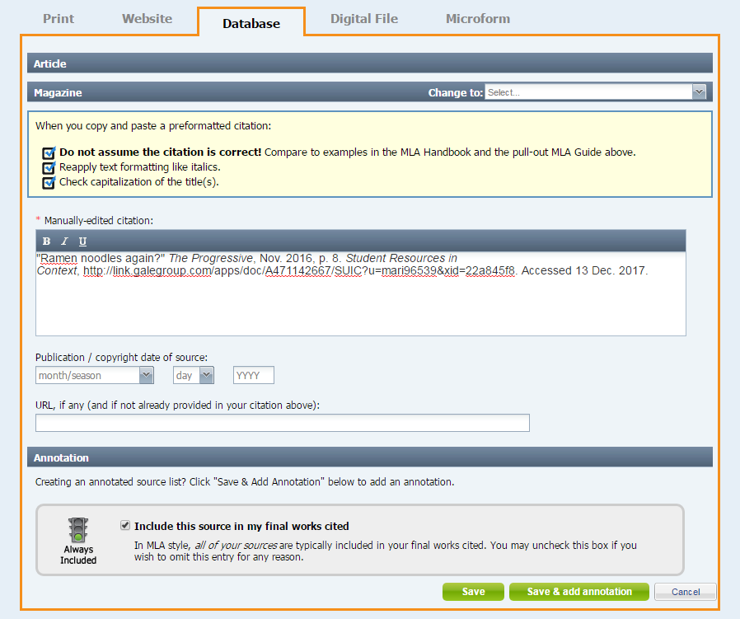
When you are done with all your citations, click “Print/Export” at the top and select “Print/Export to Word.”
Open document, enable editing, and double click in the header and add your last name. Double check to make sure everything looks good and don’t forget to save it.

